Creating  Github account

Task 1:

Create a repository in git hub

Task 2:

Add a filr to your repo using GUI

Task 3:

Create a folder in your vm and create a test file 1 and 2 and try to push file1 to the repo

(use git commands)

**Git hub commands 👍**

Git status

Git init

Git add “filename”

Git commit -m “type msg”

Git clone url

Git remote add origin url

Git push origin main

Git config –global user.email “email id”

Git config –global user.name “name here”

Git status

Git log

1. First create folder & create txt file
2. Open git bash > go to the file path  ex( cd /D/Atlas )
3. Git init
4. If we needed to add something
5. echo “hi my name “ > file_name.txt
6. git add “file_name.txt”
7. git commit -m “any message”
8. Git config –global user.email “email id”
9. Git config –global user.name “name here”

1. git clone “copy the url paste here”
2. git push origin master
3. git remote add origin ”copy the url paste here”
4. git push origin master
5. login popup will come, authenticate

Worked on branch : 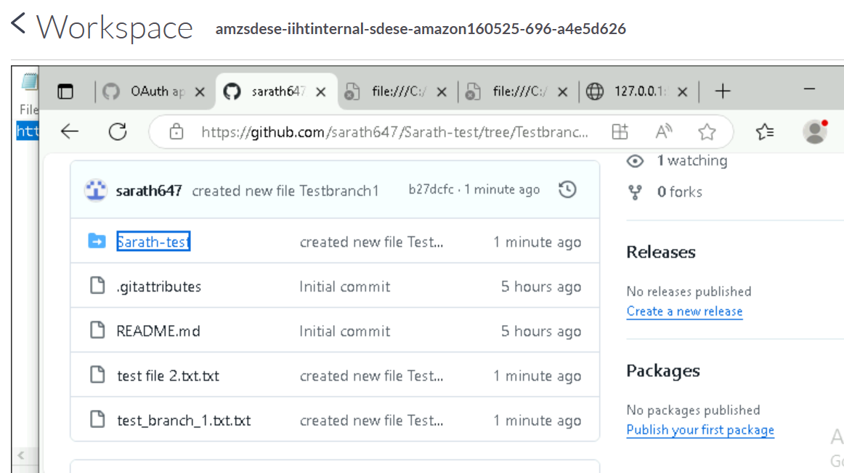

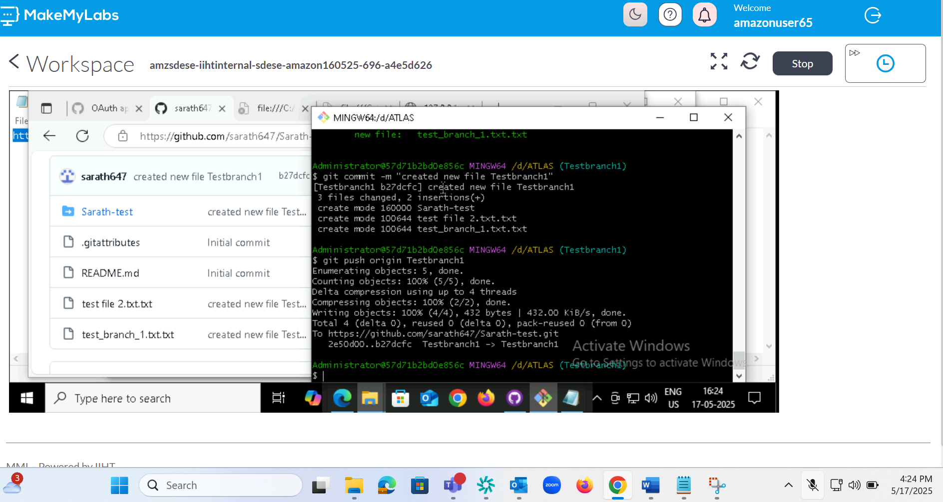

Command

Git branch -a

Git pull

Check git branch -a

Git checkout <branchname>

Go to folder and create new file

Check git status

Git add .

Git commit -m “crate new title in Testbranch1”

Git push origin Testbranch1

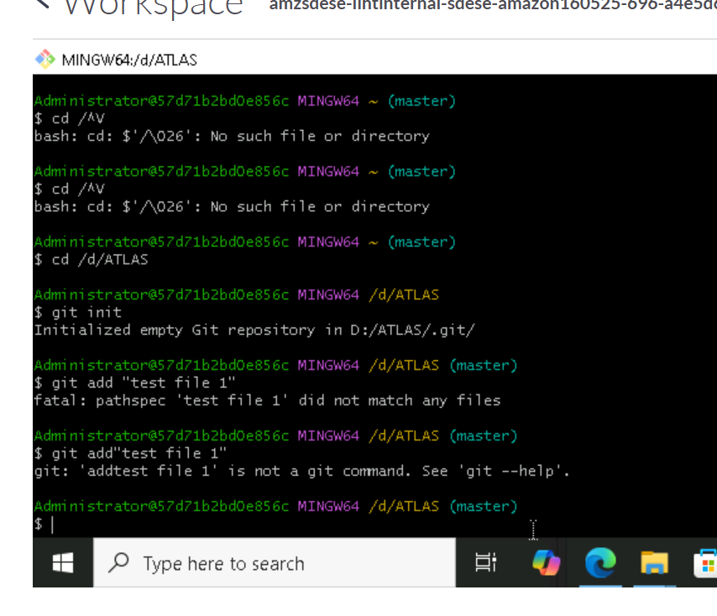

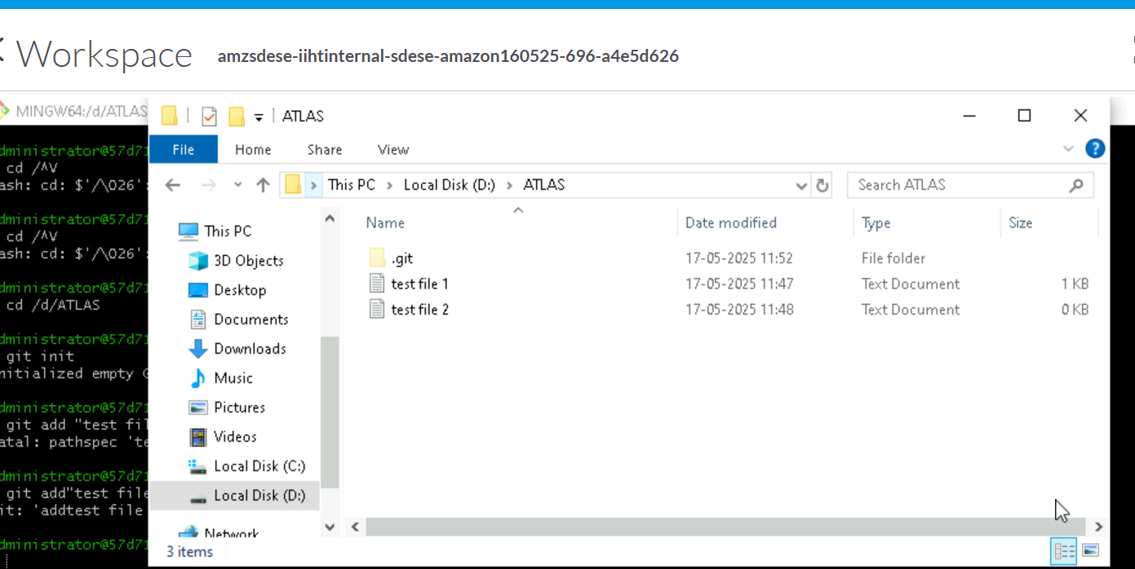

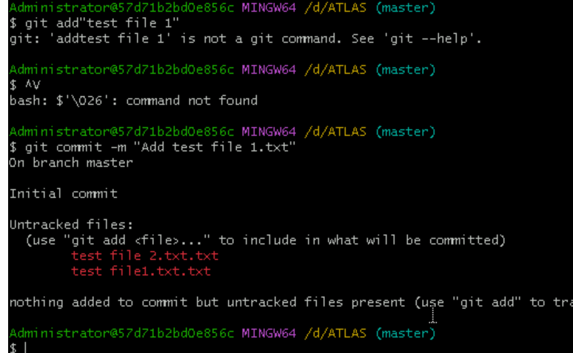

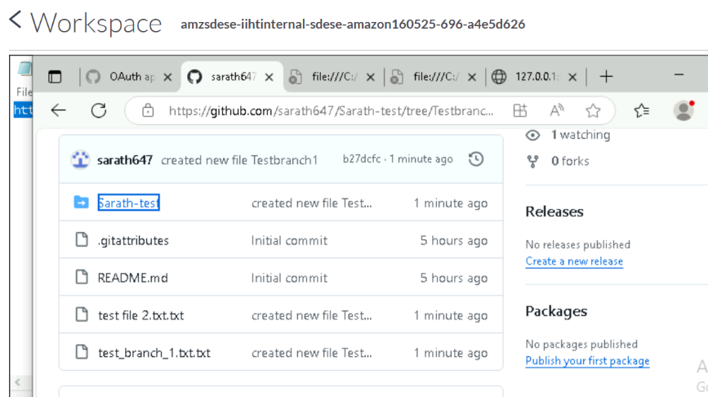

Merge

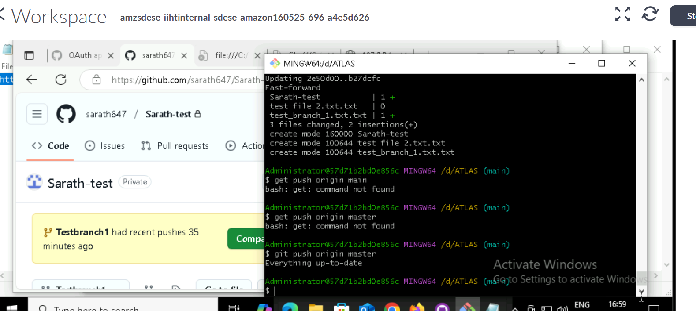

Clone

